# FEATURES: -

**LMS PROJECT WORK (teck-team-solutions)**

OVERVIEW ON WEBSITE (what are the things to display for end-users):

1. Explore courses according to the category
2. Search any course with the keyword
3. Free and paid courses
4. About us page
5. Contact us page
6. FAQ page
7. Support.
8. Join as a student and enroll in courses
9. Join as a teacher and upload content.

# Frontend part:

1. Login/register/OTP verify via email.
2. Forget password/change password.
3. Profile/social accounts.
4. Send messages to enrolled students.
5. Category CRUD (operations).
6. Upload content according to category
   1. If the video status is true (some indication) then it can access anyone without enrolling.
   2. If the video status is false then it can access only by enrolled students.
7. Upload study material according to the course.
8. Can see the total enrolled students and their progress.
9. Count total views of content.

# STUDENT PANEL:

1. Login/register/OTP verify via email.
2. Forget password/change password.
3. Enrolled courses
   1. Each enrolled courses show the video in sequence
   2. When the previous video is the student access the next video.
4. View the profile of the content creator
5. Send a message to the content creator. (Individual or all)

**Learning Management System:**

* A learning management system is a platform that assists an organization, and dimension of its eLearning programs.
* LMS is the core technology which is used by the department of Learning and Development in an organization, whereas the training programs are managed by their main tool.
* The largest benefit of LMS is the knowledge growth between learners. This saves money, since usual training forms such as classroom or seminars-based training directly impacts the company’s outcome.
* Many companies have introduced this LMS for training their freshers and about new technologies that are introduced or to be followed by the company.

**Case study on LMS:**

* Difficulty in Identifying Learning Needs: Some people face some issues while selecting specific course so while basic training can be designed for teams, the productivity of teams rises when learning progress can be tracked and individual coaching needs are identified. By tracking all person records and activities we can design the course.
* Learning can be Expensive: By taking courses and personal mentors and strategies can make learning expensive and prove lot of money. Instead, by leveraging a learning management system, companies can develop an learning framework and cultivate a culture of continual learning.
* Lack of Access to High-Quality Online Resources: In today’s every person wants to learn in online to learn accurately. Learning managements can provide those animations and video learning to make people attract and increase their interest on learning online

**TOP LMS PLATFORMS:**

* **Moodle**

Uses self-hosted LMS

We can download it for free under the GNU General Public License

* **E-khool**

Uses desktop application LMS

We can promote domains

* **Sololearn**

Uses mobile learning LMS

We should use app

**STEPS TO DEVELOP LMS:**

* Define the idea of LMS
* Pick or build your team
* Select the required set of features
* Choose the tech stack
* Plan the structure and design
* implement it

**Types of lms :**

* Cloud based: Follows SAAS (software as a service) business model.
* Self-hosted (needed to be downloaded by the user)
* Desktop application (installed on desktop)
* Mobile application. (Mobile learning)

# ADMIN PANEL:

1. Manage everything in all panels
2. Search anything
3. Add/update /delete any content
4. Enable or disable any course, student or teacher.

**Home page** :-I have created this home page using the basic frontend part this is used for the user-friendly interaction.

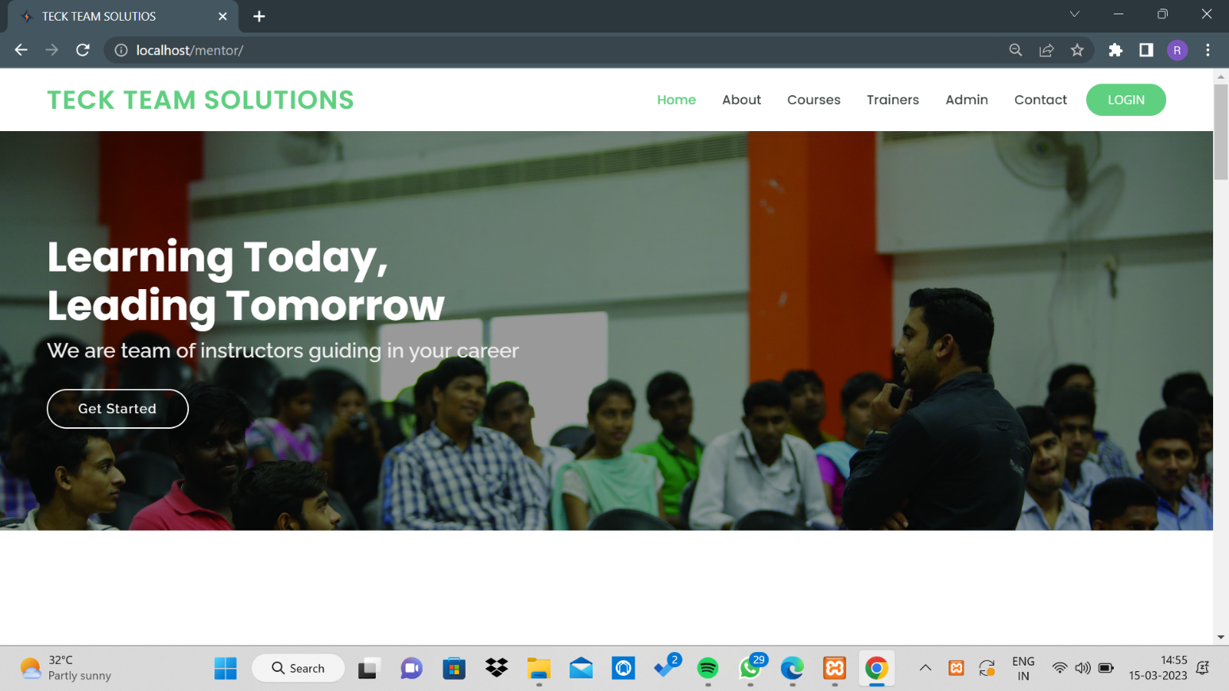

Created a backend form page using Django rest-Framework Frame work to fetch data from the frontend to backend admin panel

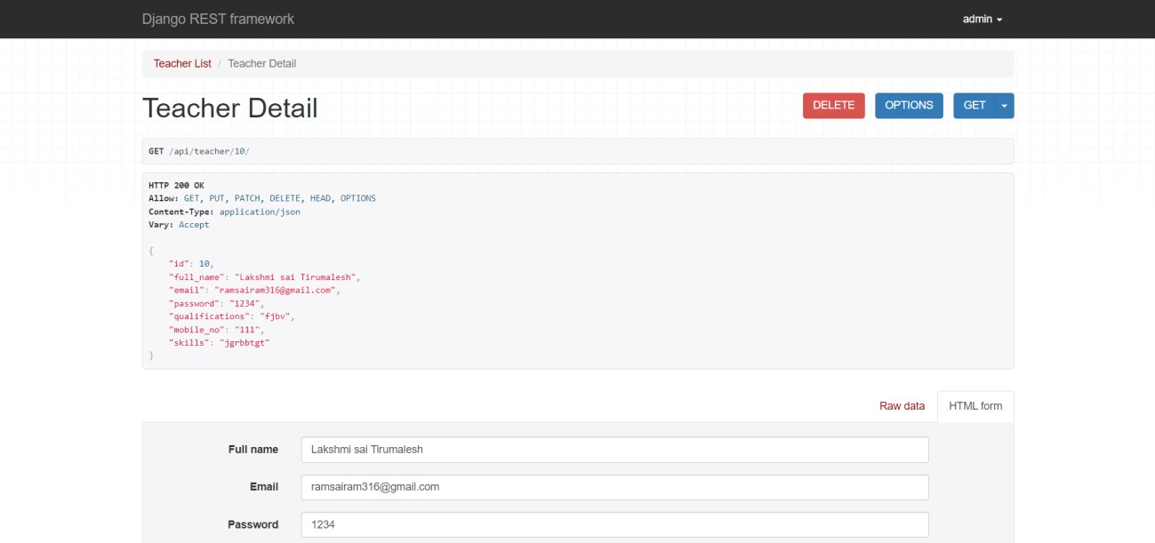

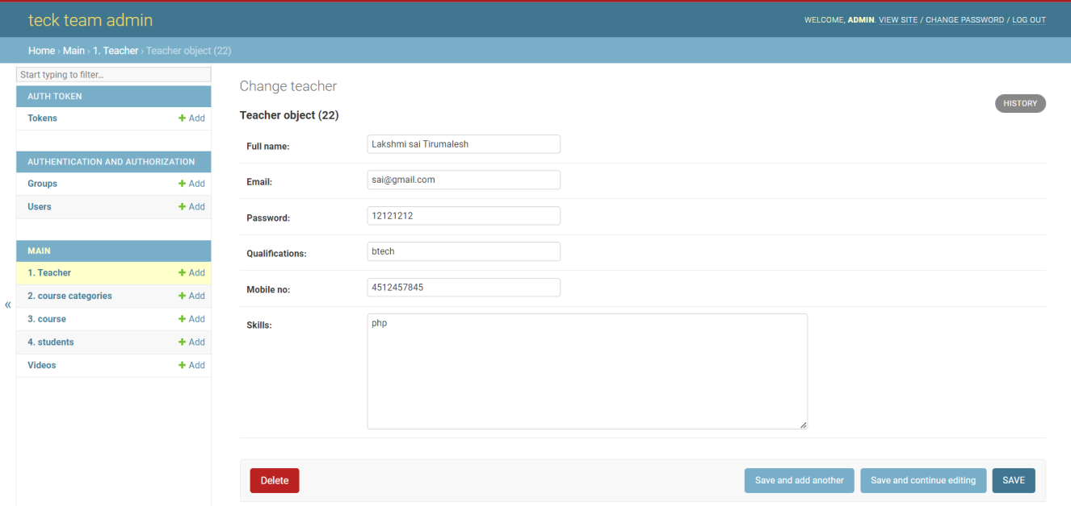

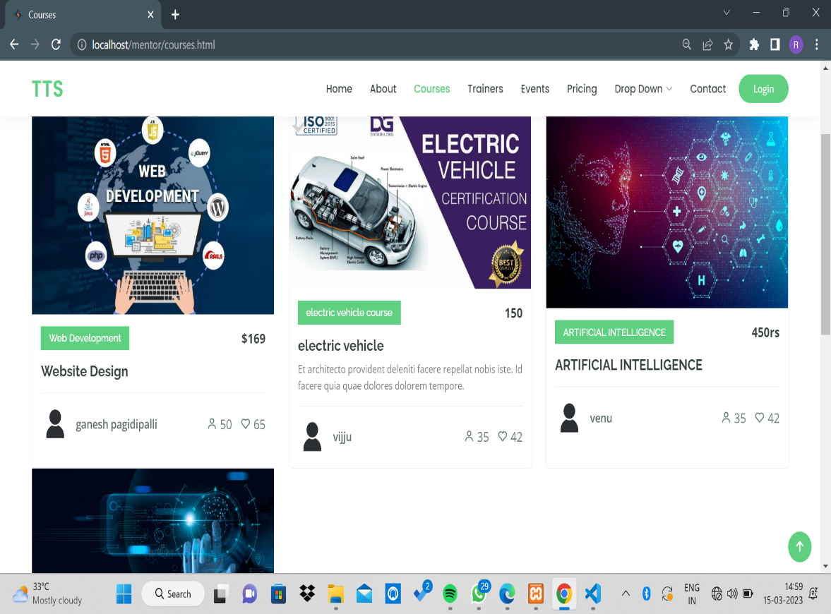

I have done the user friendly courses page for users to know about the course in a creative way.

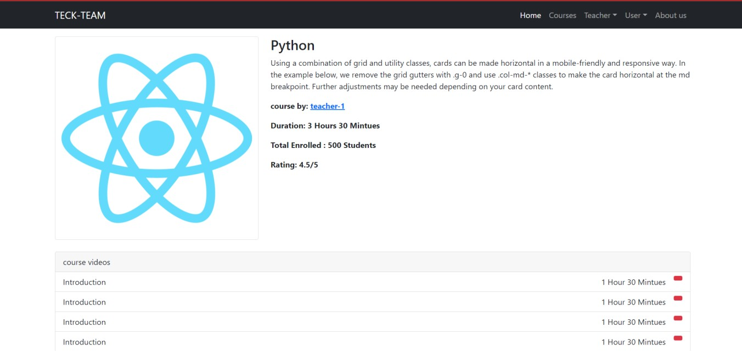

Create a teacher profile with their courses and skills and the list of courses they have will displayed in the teacher profile interface.

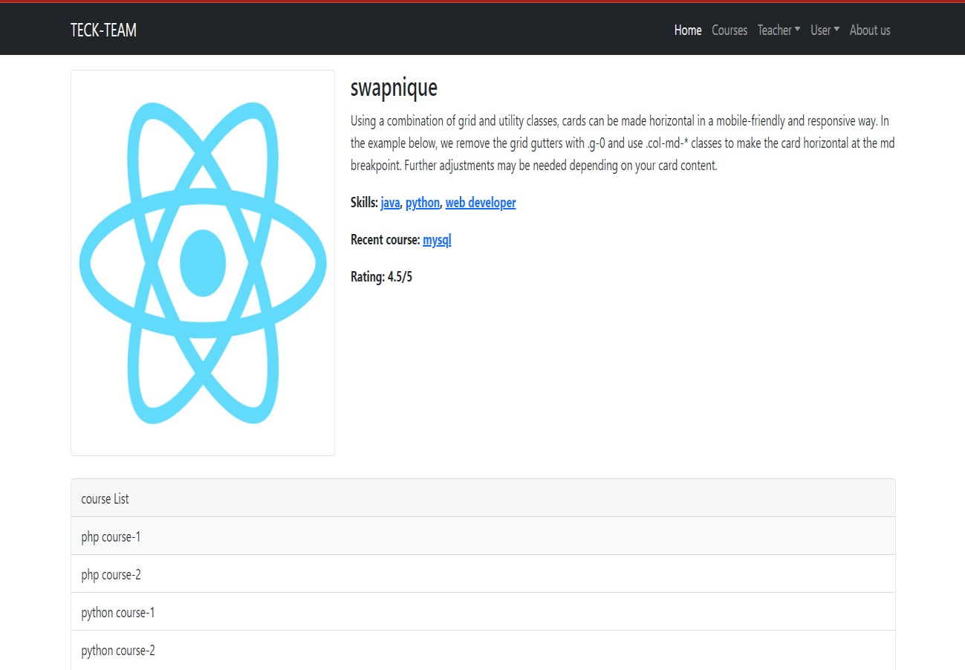

In this teacher registration page is added in which they can register and the data will be fetched to Rest frame-work and then added into admin panel with unique id numbers.

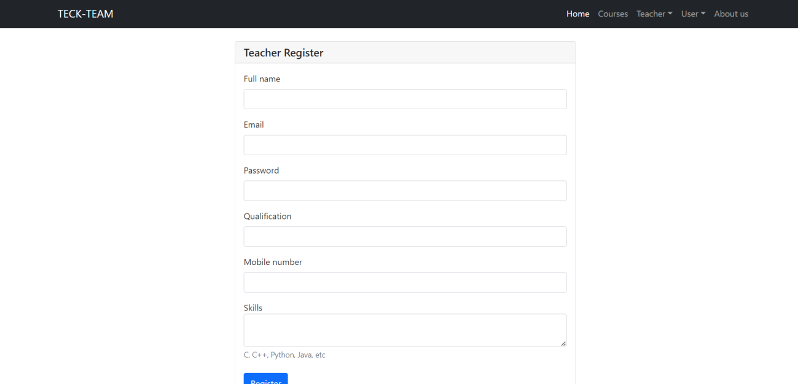

Created a teacher dashboard in which It contains my courses, add course, my users, profile settings, change password, logout

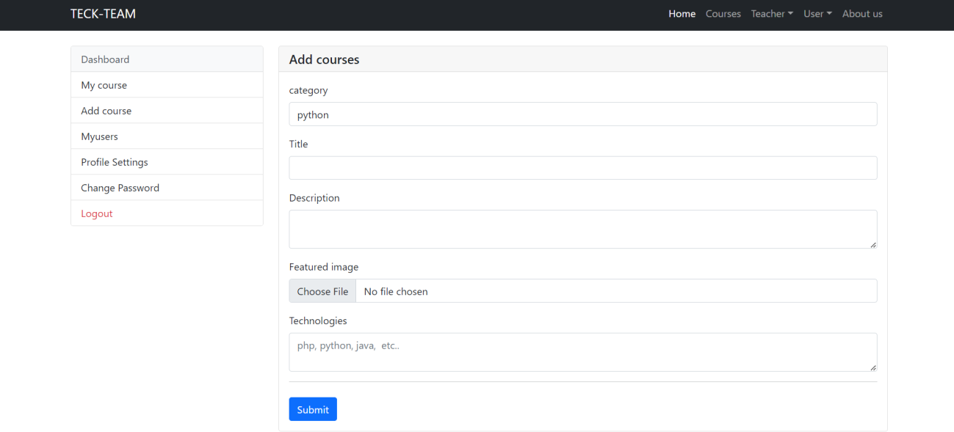

This is students registeration and fetch data to backend and admin panel

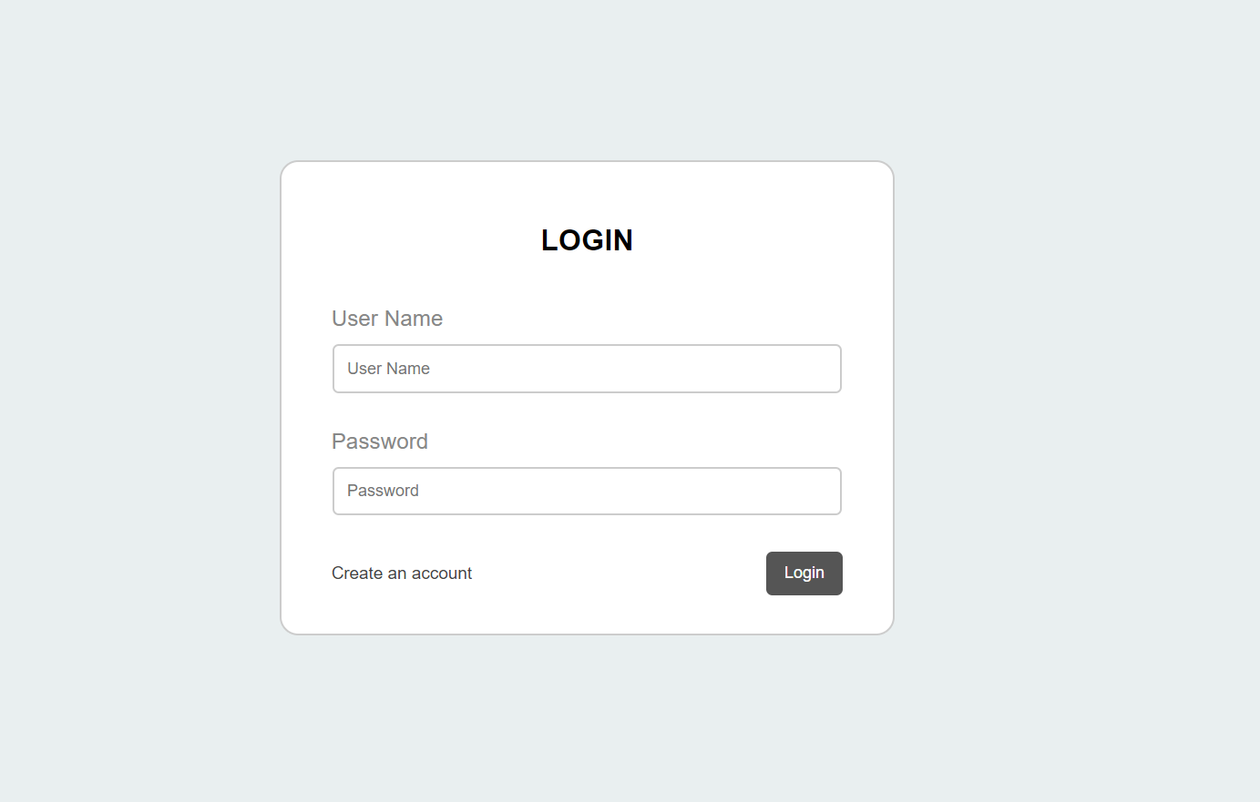

In this the added course and course chapters will be added and fetched Into this admin panel and we can use CRUD operations in the admin panel by super-admin.

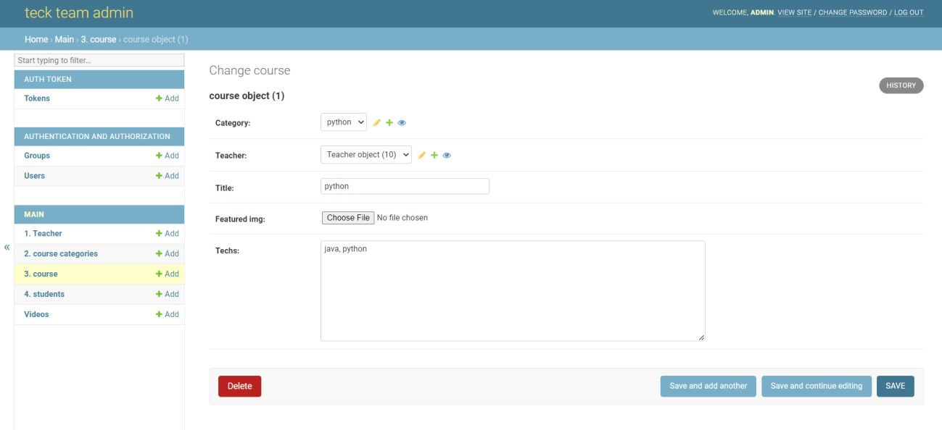

In this videos can be uploaded and storage will be given and added with caption which will updated on react js interface by admin.

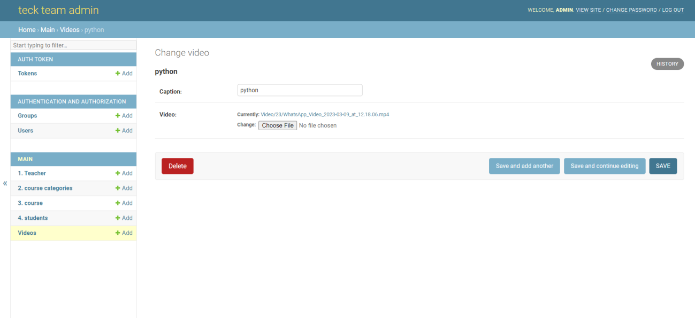

Faculty scroll bar page is been created for the users to know about the faculty.

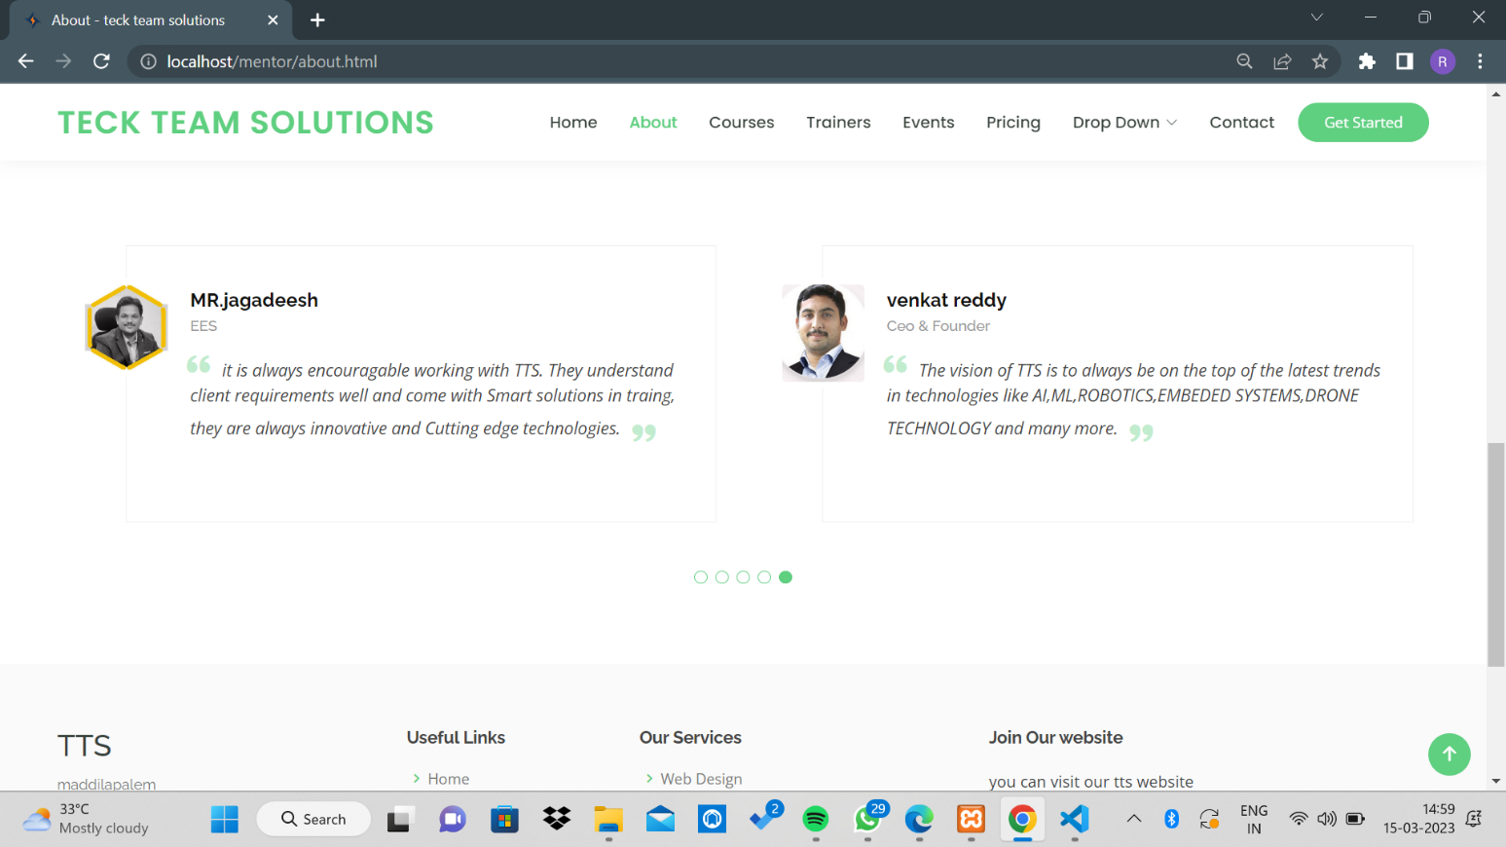

In this, everything will be stored in php (database language) my admin in this everything will be stored in the form of authenticate tokenization.

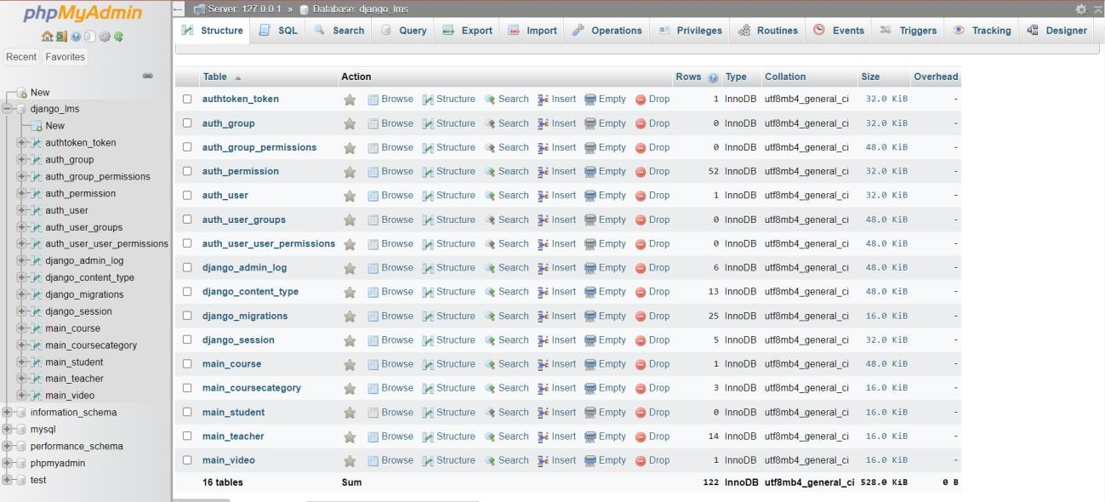

Technologies we are using in this LMS project:- Front-end technologies:-

1. Html
2. Css
3. Javascript
4. Reactjs

Back-end technologies:-

1. Python
2. Django
3. Django rest-frame-work
4. Restapi
5. Nodejs
6. Postman api

R.swapnique

Thank you